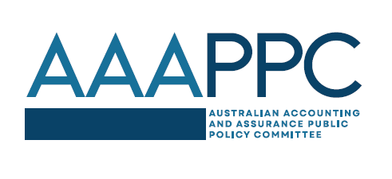 | Promoting and enhancing confidence in the Australian multidisciplinary accounting and assurance profession recognising our public interest responsibility

Australian Public Policy Committee rebrands and launches new website
The Australian Public Policy Committee (APPC) has announced its rebranding to the Australian Accounting and Assurance Public Policy Committee (AAAPPC). The change reflects the group’s ongoing focus on promoting and enhancing confidence in Australia’s multidisciplinary accounting and assurance profession, recognising its public interest responsibility.
The committee represents the country’s six largest audit firms - Deloitte, EY, KPMG, PwC, BDO and Grant Thornton. The AAAPPC will continue providing a voice for the profession, advocating for policies that promote transparency, accountability, and investor confidence.
Coinciding with the rebrand, the AAAPPC has launched a new website, providing a modern and accessible platform for stakeholders to engage with the committee. The website features updated information on the AAAPPC's policy positions, submissions, and advocacy efforts.
"The rebranding reflects our commitment to addressing the evolving needs of stakeholders and promoting high-quality financial reporting and auditing standards," said Shaun Kendrigan Chair of the AAAPPC.
"Our new website will enhance our ability to communicate with stakeholders and provide timely insights on key policy issues whilst ensuring our work, constitution and membership are transparent and accessible.”
The AAAPPC looks forward to continuing its constructive engagement with policymakers, regulators, and other stakeholders to promote a robust and efficient financial reporting framework in Australia.
For more information, please visit the AAAPPC's new website: www.aaappc.org
Background:
The Australian Accounting and Assurance Public Policy Committee (AAAPPC) represents the six largest audit firms in Australia. The AAAPPC originated in the 1990s as the Australian Public Policy Committee and included the major professional bodies as members. It was reconstituted and rebranded to the AAAPPC in 2025. Based on the Global Public Policy Committee, the professional bodies are invited to participate in AAAPPC Working Groups on an invitation basis.

